**Week 2 Lab Report**

This document contains the template you will use to complete this assignment. Save the file by adding your last name to the filename (e.g. CIS246_W2_Lab_Report_EK_Smith.docx).

Follow the steps for this week’s lab. At various points in the instructions, you will be asked to answer a question or capture a screenshot to document your work – type your answers and place screenshots into this document, then submit this completed Lab Report to the appropriate weekly Dropbox.

**Lab 2a: Install and Configure Active Directory**

1. Is the firewall turned on? (3 points)

The firewall is listed as:

Public: Off

2. How do you turn off the IE Enhanced Security Configuration.? (3 points)

In the bottom right group box, you click on the link labeled ‘Configure IE ESC’

3. Which link allows you to change the computer name? (3 points)

You click on the link in the top right group box labeled ‘Change System Properties’ and then in the window that pops up you click on ‘Change’ to rename the computer.

***Screenshots***

#1 configuration screen (3 points)

The directions are not specific in which “configuration screen” to include a screenshot of, so I will include both relevant configuration screens:

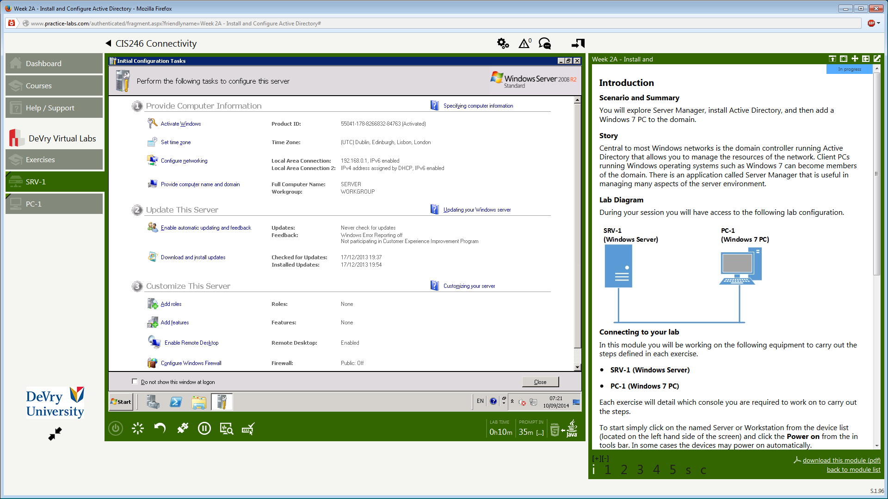

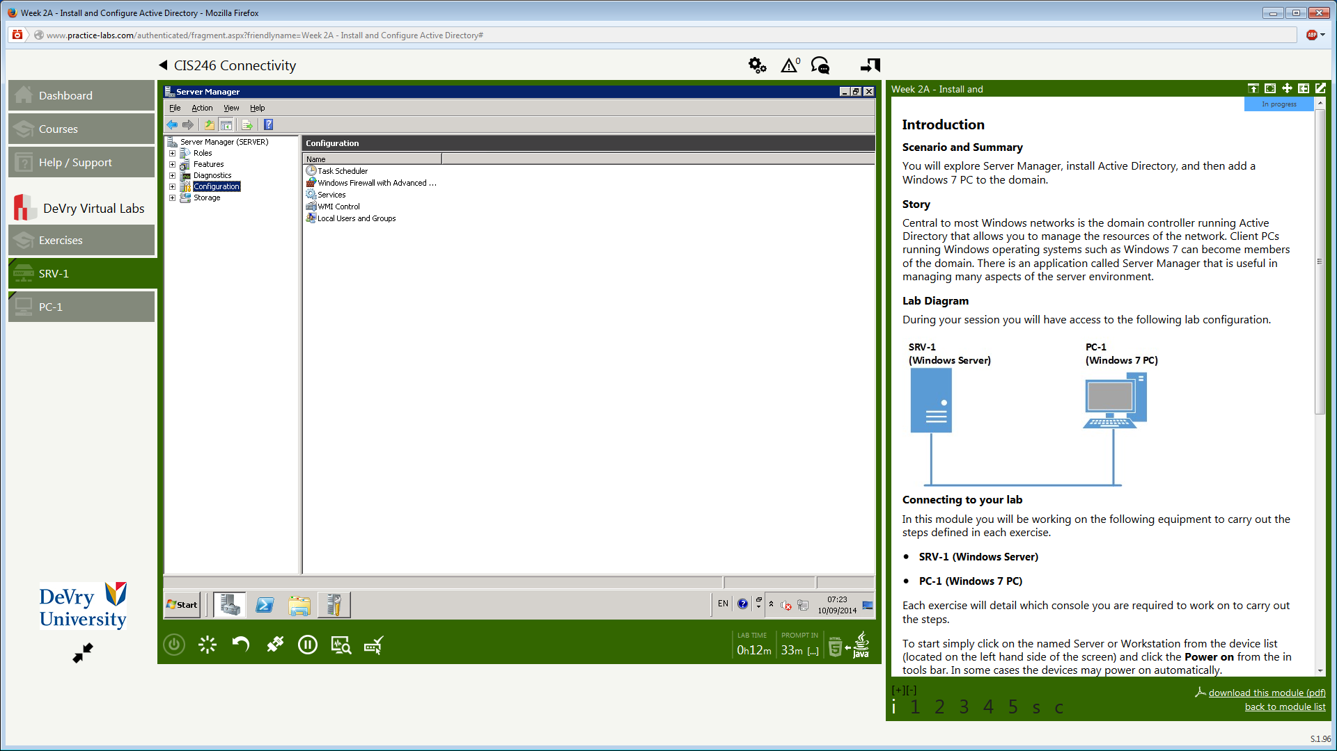

#2 First Diagnostic screen (3 points)

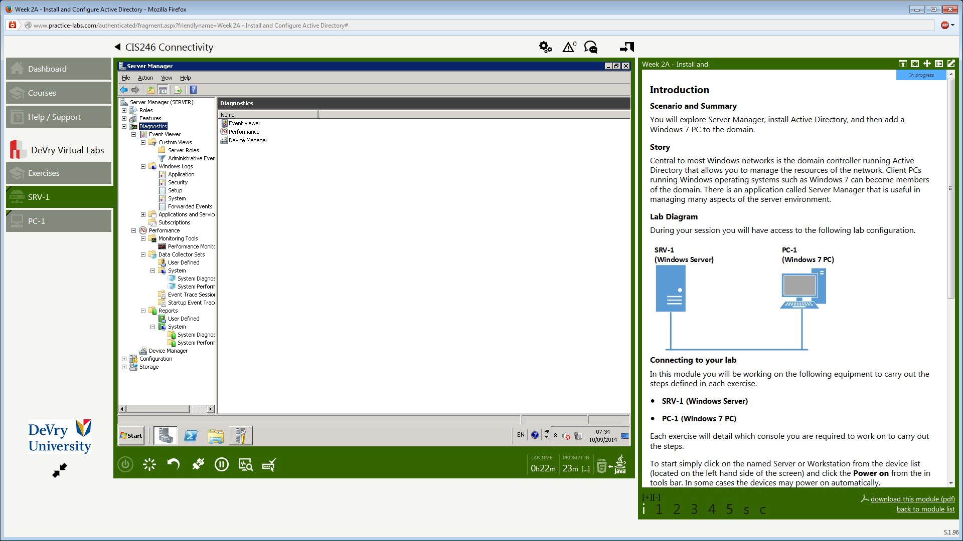

#3 Scroll down to get the rest of the Diagnostics screen (3 points)

Following the directions and NOT expanding ‘Event Viewer > Applications and Services’ there is nothing that does not fit in ‘Diagnostics’ in the left pane, so I think the same screenshot should suffice.



#4 Screenshot of telnet command (4 points)

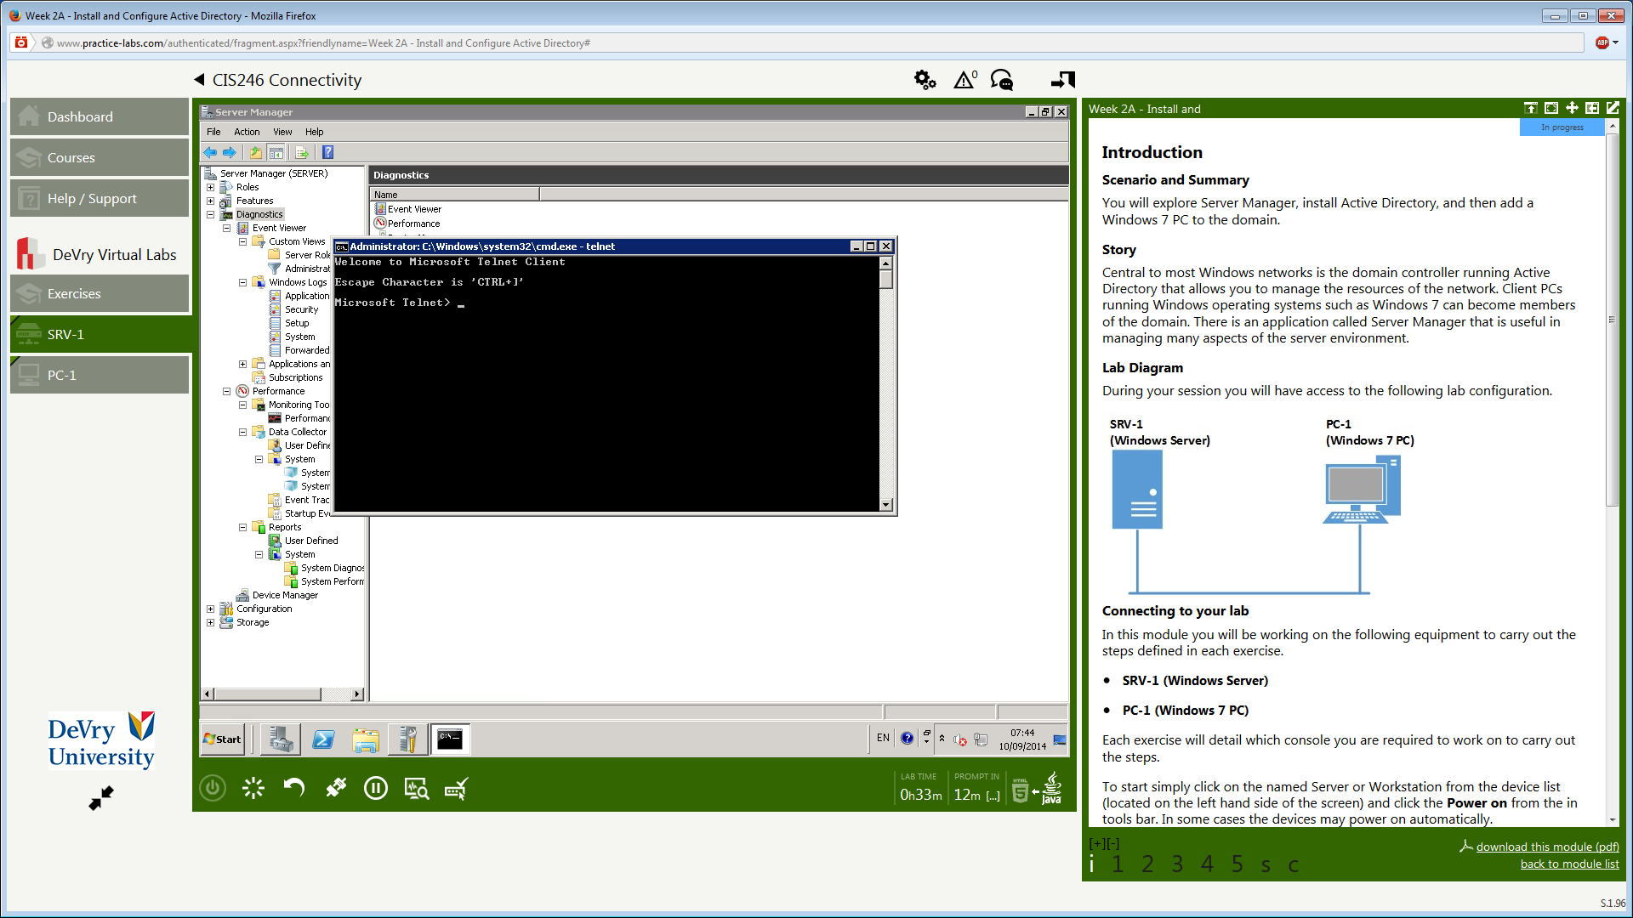

#5 Active Directory installed. Computer name including domain name (4 points)

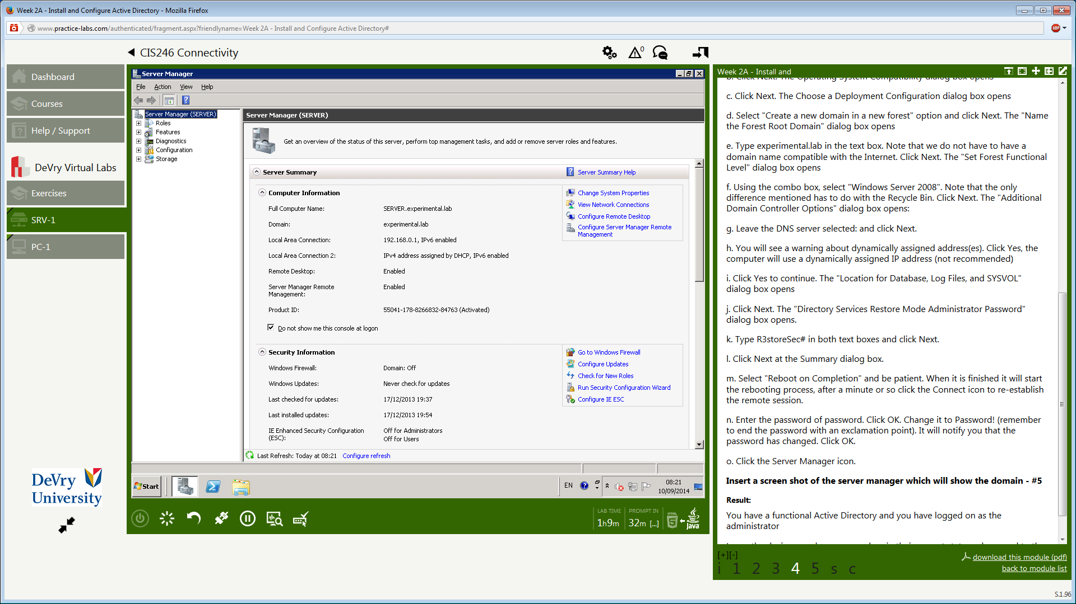

#6 Windows 7. Computer name including domain name (4 points)

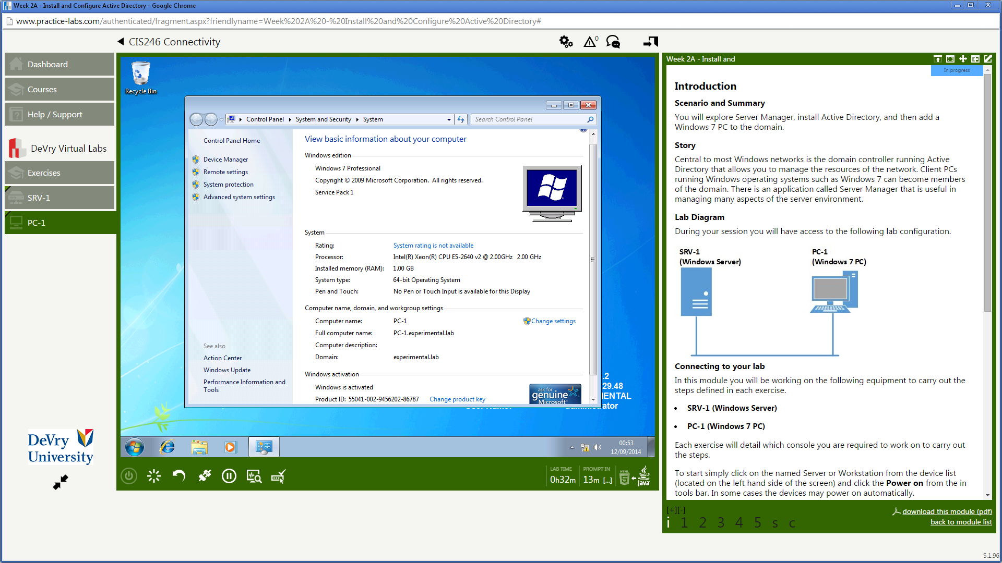

**Lab 2b: Organize Users and Groups**

***Screenshots***

#7 Your name logged on to the Windows 7 PC (4 points)

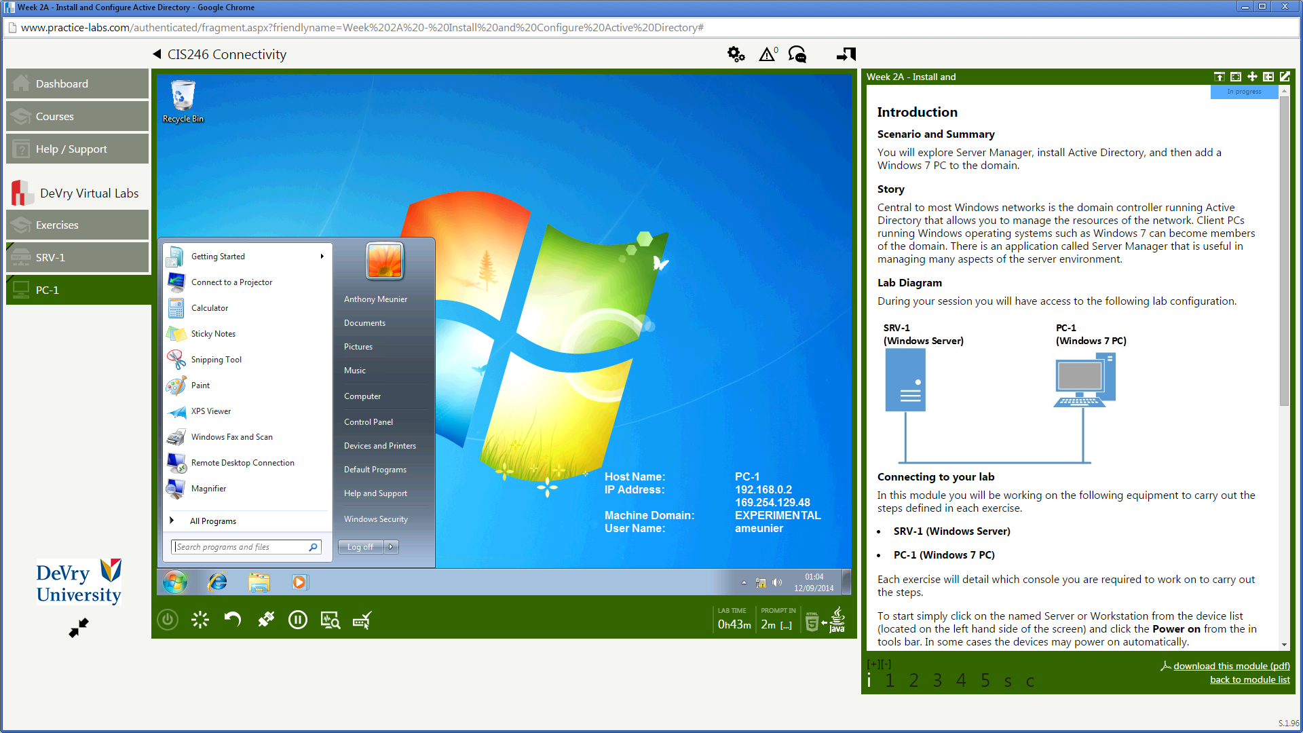

#8. The name of the user in the group (4 points)

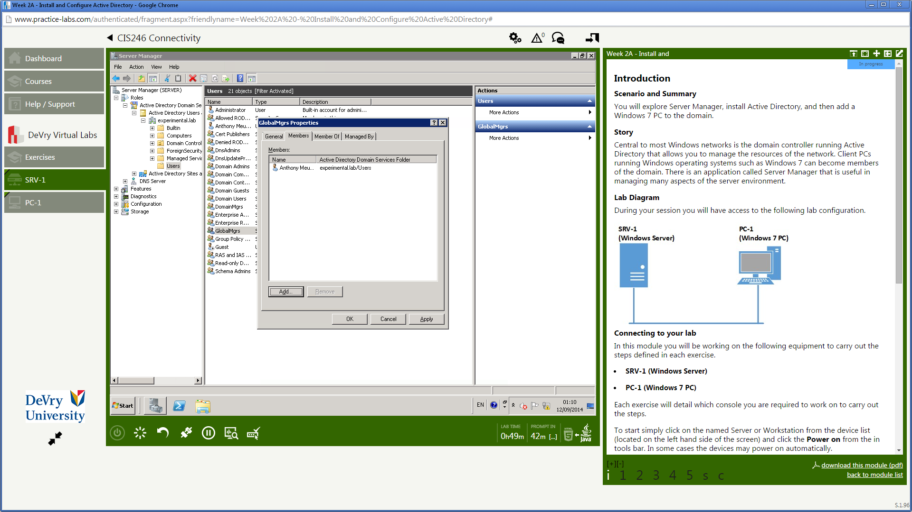

#9. Both groups in the middle panel (4 points)

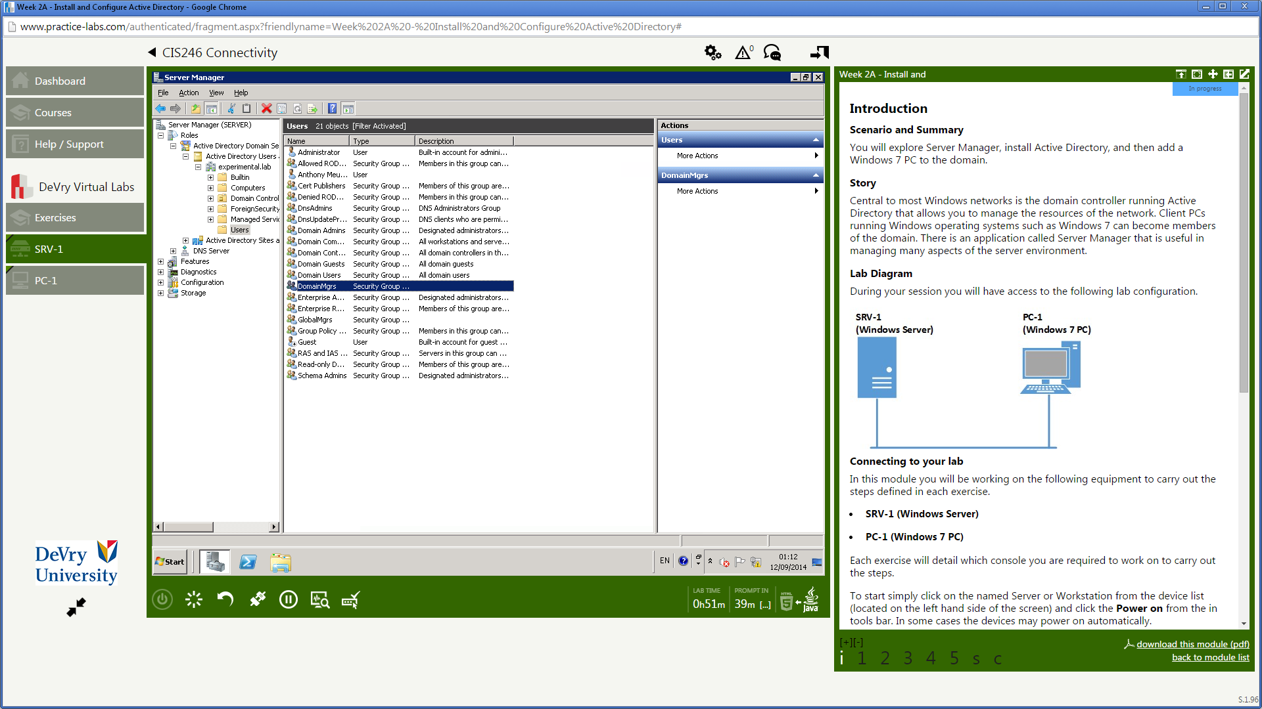

#10. Ability to delete OU (4 points)

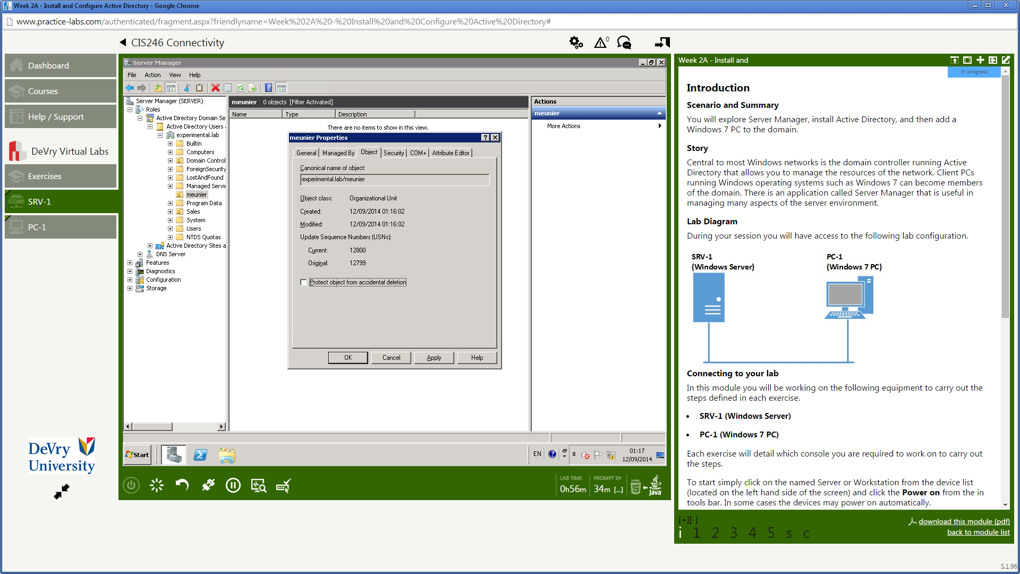

#11. Delegated user (4 points)  
